TS637 - Photoshop Skills Tasks

**For each of the below tasks, follow that the steps, and once they are complete, add them to your portfolio website, on a page called: “Photoshop”**

1. Removal of Red Eyes
   1. Using the Red Eye Photo select the spot healing brush tool then select the Red eye tool.
   2. Double click the Pupil Size data filed in the options bar and type the number 15.
   3. Double click the darken amount data field in the options bar and type the number 15.
   4. Click in the red eye area of one eye, then do the other eye.
   5. Photoshop replaces the red with a neutral grey.
   6. **Save your file calling it Red Eye Removal**
   7. Change the grey colour of the eyes to a blue.
   8. **Save your file calling it Changing eye colour to Blue**
2. Improving an Underexposed Photo – Too Dark
   1. Using the Underexposed Image duplicate the layer. (right mouse click and duplicate)
   2. Click on the blend mode up-down arrow and select Screen

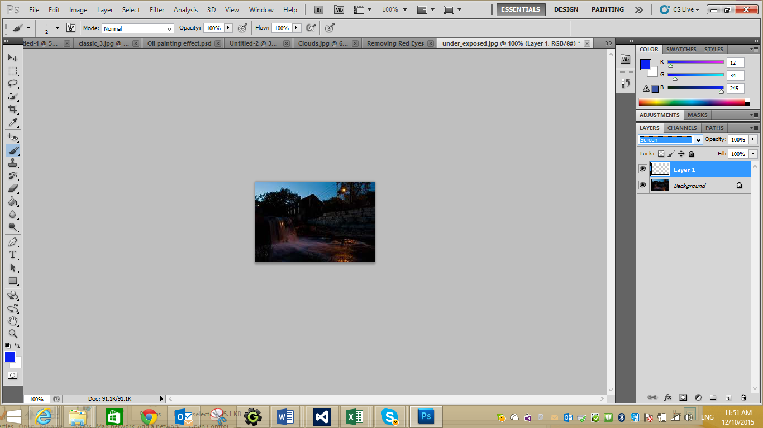

* 1. The Photo should appear lighter
  2. You may need to duplicate the layer and repeat the adjustment as above.
  3. **Save your file calling it Lightening a Photo**

1. Improving an Over Exposed Photo – Too Light
   1. Using the Over Exposed Photo duplicate the layer
   2. Click Image>Adjustments>Show/Highlight.
   3. Move the Shadows amount to 0
   4. Drag the Highlights amount to the right until the images looks good.
   5. **Save your file and Darkening a Photo**
2. Removal of a Skin Blemish
   1. Using the Remove Blemish Photo zoom in (Ctrl +)
   2. Select the Spot Healing Brush and tick the Sample all Layers in the options bar

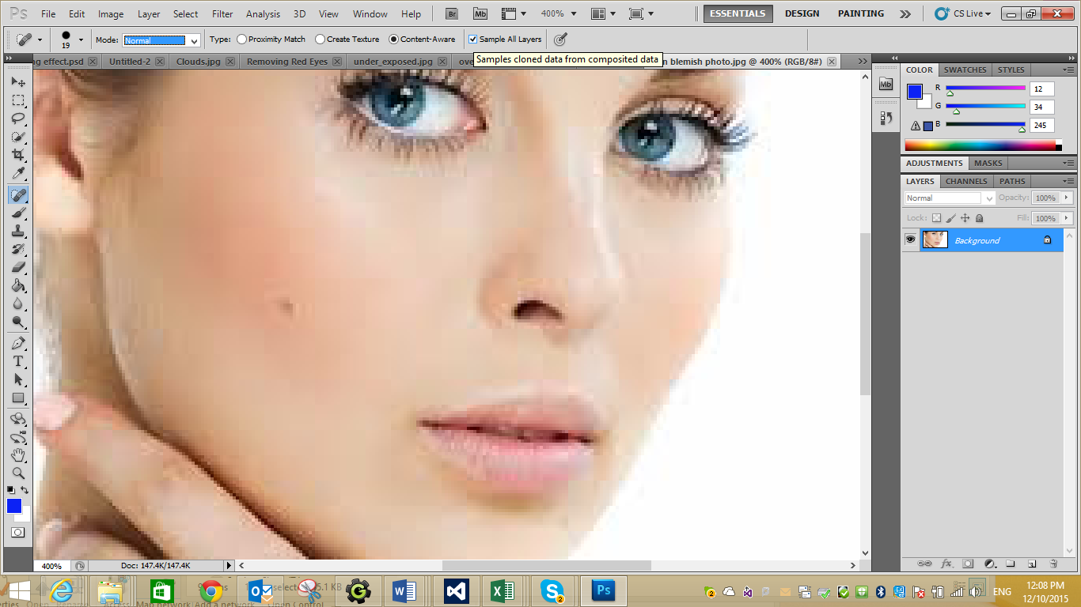

* 1. Click on the new layer icon in the layers palette to add a new blank layer.
  2. Click the brush thumbnail in the options bar to open the brush picker
  3. Click and drag the diameter slider to adjust the size of the brush. It should be just larger than the blemish (about 12)
  4. Click on the blemish. Photoshop removes the blemish blending in the surrounding skin area.
  5. **Save your file calling it Removal of Blemish**

1. Create a Soft Focus Effect
   1. Using the Soft Focus image add a new layer
   2. Click Filter>Blur>Gaussian Blur. (Drag the Radius slider until the image is blurred.
   3. Set the Radium at 20 to 50 pixels for high-resolution photos and 6 – 20 for low-resolution photos.
   4. Click OK. The image appears completely blurred
   5. Click and drag the Opacity slider in the layers palette to reduce the effect until the image appears to have a dreamy, soft focus.
   6. **Save the file calling it Soft Focus**
2. Maximising images with minimal visible loss
   1. Using the Harbour image click on Image>Resize Image
   2. Make sure the resample Image check box is checked
   3. Change the width of the image to be 500 and the resolution to 120.
   4. Select the Bicubic Sharper from the drop down arrow and click OK
   5. **Save the file calling it Maximising your Images**
3. Straightening a crooked image
   1. Using the crooked horizon image Get the Ruler tool (under the eye dropper tool)
   2. Drag the ruler from the left side of the horizon to the right

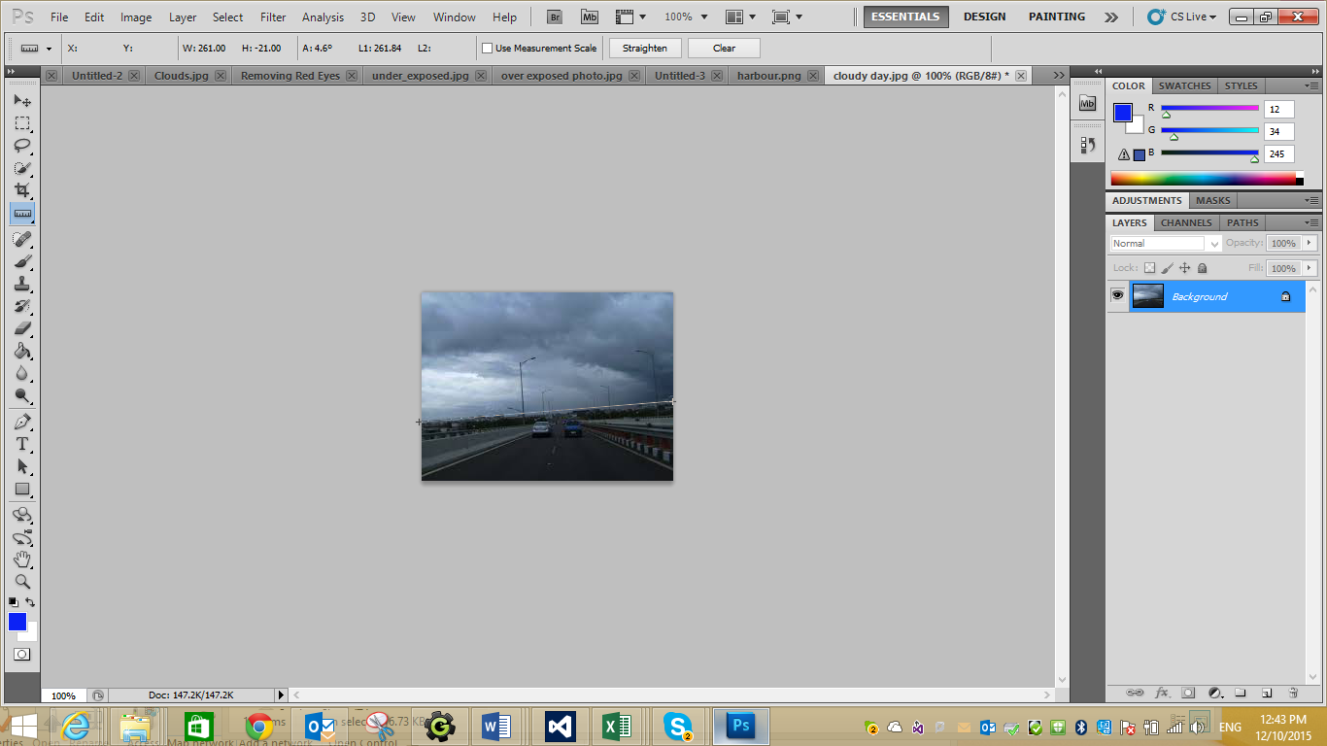

* 1. On the options bar click on straighten and the horizon will appear to level out.
  2. **Save your file calling it Straightening an Image**

1. Adding Text to your images
   1. Using the forest by lukpazera image add the following text “Dark Forest” by selecting the Text tool.
2. Changing a Black and White Photo into a Colour Photo
   1. Using the Black and White rose photo go to Image>Mode>RGB
   2. If the image is not already grayscale, choose Image>Adjustments>Desaturate
   3. Choose a painting tool (colour Replacement tool under the brush tool) and from the swatches panel choose a first colour you want to paint with (a nice red colour). Choose brush size 13.
   4. Start Painting
   5. **Save the File calling it Changing a Black and White Photo to Colour**